**Day 3:**

**Q19.** Create a class for **Hyundai** which has the members:

-**maximum speed limit**

-method:

-**SetMaxSpeed**: should set the max speed of hyundai to 120Km/Hr

-**ToString** : should display the details of maximum speed limit

Create following two derived classes inheriting Hyundai:

1) **Hyudai Era**

-methods:

-**SetMaxSpeed**: should set the max speed of hyundai to 80Km/Hr

-**ToString** : should display the details of maximum speed limit

2) **Hyudai Magna**

-methods:

-SetMaxSpeed: should set the max speed of hyundai to 70Km/Hr

-ToString : should display the details of maximum speed limit

**Q20.** A coffee shop would like to find out the customer feedback rating about its services. The customer class shown below:

**Customer**

-**FeedbackRating**: double

-**MobileNumber**: String

-**Name**: String

Example: Assume that the shop will collect feedback from ‘N’ customers. Following are the sample customer feedback values.

**Customer 1: 3 out of 5**

**Customer 2: 4 out of 5**

**Customer 3: 2.5 out of 5**

Write an application which creates array of ‘N’ customer objects to store feedback values of these customers and print the average feedback rating.

**Q21.** An agency which works for a bank takes care of background verification of a customer who had applied for a personal loan. The agency will go through background check and classify the customer into two categories: “Green” and “Red”.

**Example:**

If a customer has good financial transaction history, he/she will be categorized as “Green”.

If a customer has poor financial transaction history, he/she will be categorized as ‘Red”.

Based on category, the bank will decide to approve the loan request. Below is the class diagram.

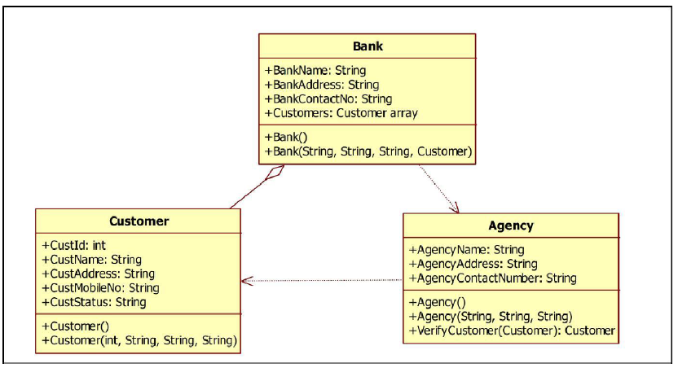

Write an application which implements above scenario: The class “Agency” has method called: VerifyCustomer(Customer), which accepts Customer object as an argument, changes the status of “CustStatus” either to “Green” or “Red”. Return the updated Customer object.

Note: The initial value of “custStatus” of Customer class must be “null”.

**Q23.** In an organization, the salary component varies from an employee to employee. Below is the class diagram which depicts different types of an employee. An abstract class called ‘Employee’ has an abstract method ‘calculateSalary()’, which must be overridden in each of derived classes: Trainee, TeamLead and Manager.

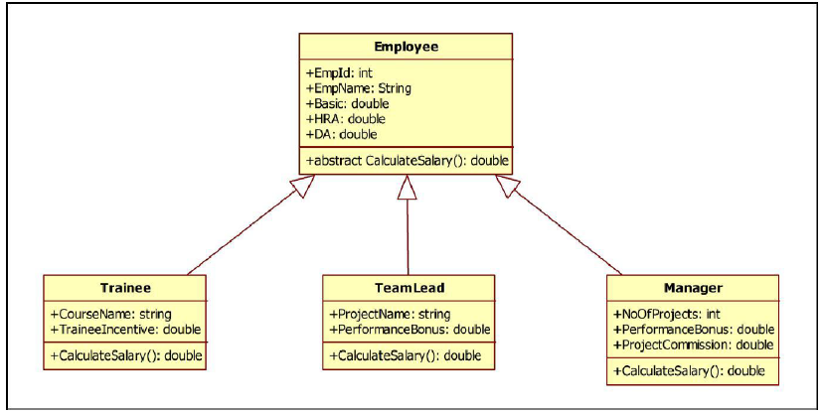

Each employee will have common salary components: Basic, DA and HRA, other components vary among different employees.

**Example:**

* For a team lead, salary will be calculated as: Basic+HRA+DA+performanceBonus
* For a manager, salary will be calculated as: Basic+HRA+DA+performanceBonus+projectCommission
* For a trainee, salary will be calculated as: Basic+traineeIncentive  

Write an application which implements above scenario and write main method to test your code.